Figure 6
Connections over 200 kbps in at Least One Direction 2012-2016
(In thousands)

 | 2012 | 2013 |  | 2014 |  | 2015 |  | 2016
Technology | Dec | Jun | Dec | Jun* | Dec | Jun | Dec | Jun | Dec
Total | 262,564 | 284,692 | 293,397 | 311,284 | 321,305 | 342,096 | 355,229 | 369,431 | 376,221
Total Fixed | 92,511 | 93,986 | 96,032 | 95,998 | 97,810 | 100,134 | 102,212 | 104,056 | 105,727
Mobile Wireless | 170,053 | 190,706 | 197,365 | 215,286 | 223,495 | 241,962 | 253,017 | 265,375 | 270,494

Figure 7
Residential Connections over 200 kbps in at Least One Direction 2012-2016
(In thousands)

 | 2012 | 2013 |  | 2014 |  | 2015 |  | 2016
Technology | Dec | Jun | Dec | Jun* | Dec | Jun | Dec | Jun | Dec
Total | 215,817 | 235,273 | 246,797 | 264,343 | 273,950 | 292,279 | 303,655 | 316,467 | 322,364
Total Fixed | 84,392 | 85,277 | 87,599 | 87,360 | 89,196 | 91,419 | 93,430 | 94,979 | 96,616
Mobile Wireless | 131,425 | 149,996 | 159,197 | 176,983 | 184,754 | 200,859 | 210,224 | 221,489 | 225,749

* The June 2014 data have not been subjected to the typical quality checks (see Technical Notes).

The Commission approved changes to the Form 477 in June 2013 that affect the data beginning in June 2014 (see Technical Notes). Some previously-published
data may have been revised. Figures may not sum to totals elsewhere in this report due to rounding.

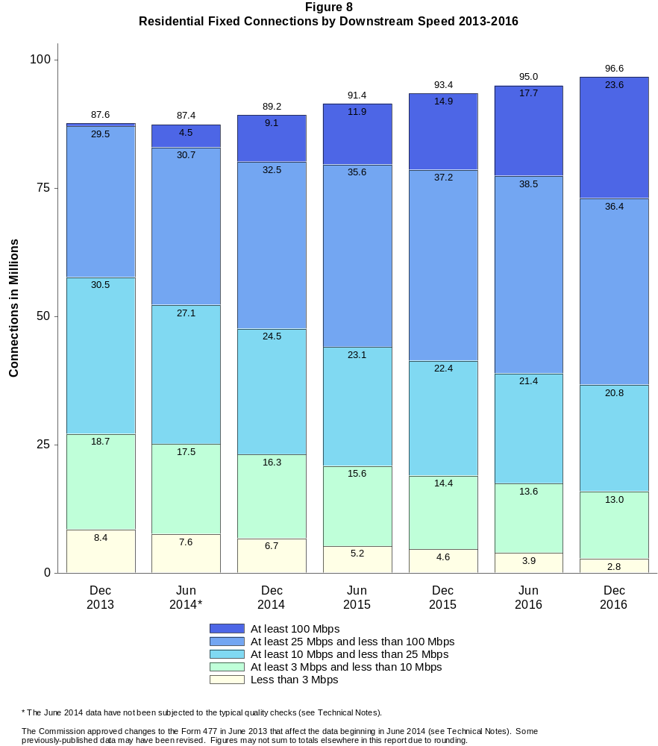

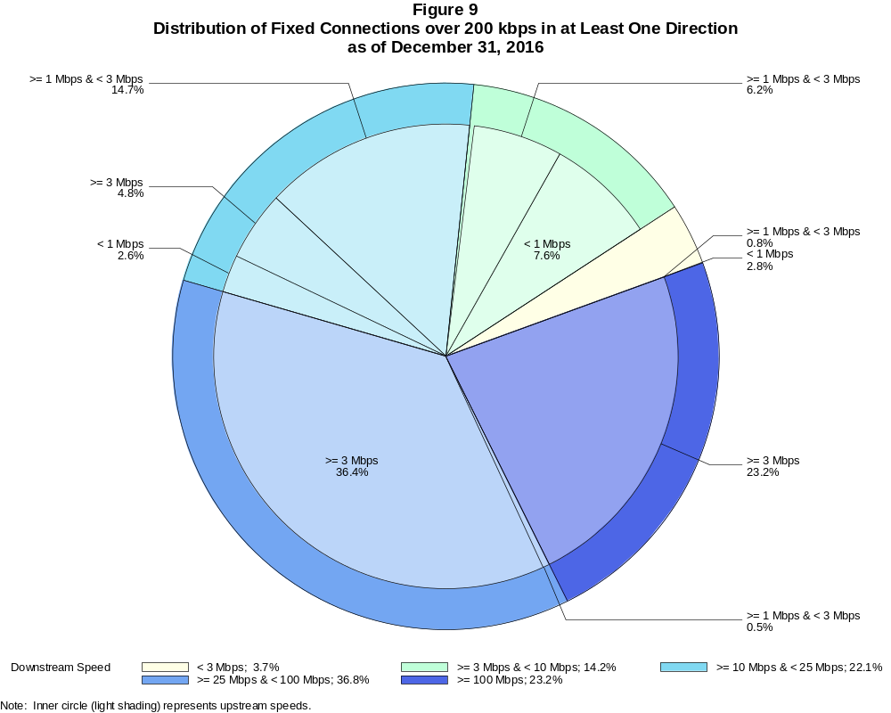

Fixed Connections over 200 kbps in at Least One Direction (in thousands)

 | Downstream Speed
Upstream Speed | Less than 3 Mbps | At least 3 Mbps  and less than 10 Mbps | At least 10 Mbps  and less than 25 Mbps | At least 25 Mbps  and less than 100 Mbps | At least 100 Mbps | Total
Less than 1 Mbps | 2,989 | 8,063 | 2,762 | # | # | 13,815
At least 1 Mbps & Less than 3 Mbps | 879 | 6,566 | 15,532 | 495 | 6 | 23,477
At least 3 Mbps | # | 336 | 5,113 | 38,452 | 24,535 | 68,436
Total | 3,868 | 14,964 | 23,407 | 38,946 | 24,541 | 105,727

Percentages

Less than 1 Mbps | 2.8 | 7.6 | 2.6 | 0.0 | 0.0 | 13.1
At least 1 Mbps & Less than 3 Mbps | 0.8 | 6.2 | 14.7 | 0.5 | 0.0 | 22.2
At least 3 Mbps | 0.0 | 0.3 | 4.8 | 36.4 | 23.2 | 64.7
Total | 3.7 | 14.2 | 22.1 | 36.8 | 23.2 | 100.0

Note: Figures may not sum to totals due to rounding. # = Rounds to zero.
Source: FCC Form 477.

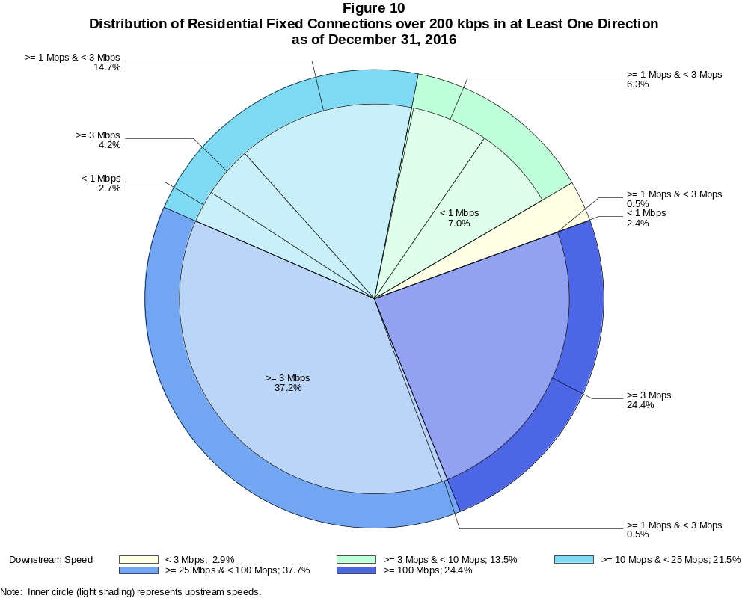

Residential Fixed Connections over 200 kbps in at Least One Direction (in thousands)

 | Downstream Speed
Upstream Speed | Less than 3 Mbps | At least 3 Mbps  and less than 10 Mbps | At least 10 Mbps  and less than 25 Mbps | At least 25 Mbps  and less than 100 Mbps | At least 100 Mbps | Total
Less than 1 Mbps | 2,361 | 6,756 | 2,571 | # | # | 11,688
At least 1 Mbps & Less than 3 Mbps | 447 | 6,108 | 14,158 | 449 | 4 | 21,166
At least 3 Mbps | # | 153 | 4,068 | 35,933 | 23,608 | 63,761
Total | 2,808 | 13,018 | 20,796 | 36,382 | 23,612 | 96,616

Percentages

Less than 1 Mbps | 2.4 | 7.0 | 2.7 | 0.0 | 0.0 | 12.1
At least 1 Mbps & Less than 3 Mbps | 0.5 | 6.3 | 14.7 | 0.5 | 0.0 | 21.9
At least 3 Mbps | 0.0 | 0.2 | 4.2 | 37.2 | 24.4 | 66.0
Total | 2.9 | 13.5 | 21.5 | 37.7 | 24.4 | 100.0

Note: Figures may not sum to totals due to rounding. # = Rounds to zero.
Source: FCC Form 477.

Figure 11
Connections over 200 kbps in at Least One Direction by Technology 2012-2016
(In thousands)

 | 2012 | 2013 |  | 2014 |  | 2015 |  | 2016
Technology | Dec | Jun | Dec | Jun* | Dec | Jun | Dec | Jun | Dec
Total | 262,564 | 284,692 | 293,397 | 311,284 | 321,305 | 342,096 | 355,229 | 369,431 | 376,221
Total Fixed | 92,511 | 93,986 | 96,032 | 95,998 | 97,810 | 100,134 | 102,212 | 104,056 | 105,727
aDSL | 30,974 | 30,657 | 30,690 | 29,873 | 28,527 | 29,341 | 28,131 | 27,489 | 26,526
sDSL | 132 | 117 | 108 | 96 | 85 | 75 | 60 | 56 | 42
Other Wireline¹ | 796 | 769 | 772 | 792 | 723 | 682 | 693 | 673 | 673
Cable Modem | 51,646 | 52,760 | 54,009 | 54,011 | 56,301 | 57,243 | 59,706 | 61,456 | 63,352
FTTP² | 6,733 | 7,250 | 7,745 | 8,326 | 9,180 | 9,687 | 10,499 | 11,125 | 12,041
Satellite | 1,454 | 1,623 | 1,849 | 1,964 | 2,006 | 2,058 | 2,071 | 2,079 | 1,864
Fixed Wireless | 777 | 810 | 858 | 935 | 988 | 1,049 | 1,052 | 1,179 | 1,230
Mobile Wireless | 170,053 | 190,706 | 197,365 | 215,286 | 223,495 | 241,962 | 253,017 | 265,375 | 270,494

¹ Power Line and Other are summarized with Other Wireline to maintain firm confidentiality. See Technical Notes at the end of the report for a description of
Form 477 technology categories and other reporting requirements.
² Fiber to the premises.
* The June 2014 data have not been subjected to the typical quality checks (see Technical Notes).

The Commission approved changes to the Form 477 in June 2013 that affect the data beginning in June 2014 (see Technical Notes). Some previously-published
data may have been revised. Figures may not sum to totals due to rounding.

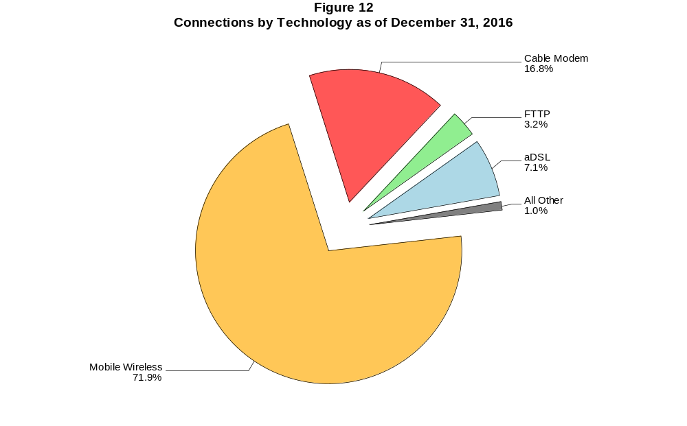

Figure 13
Residential Connections over 200 kbps in at Least One Direction by Technology 2012-2016
(In thousands)

 | 2012 | 2013 |  | 2014 |  | 2015 |  | 2016
Technology | Dec | Jun | Dec | Jun* | Dec | Jun | Dec | Jun | Dec
Total | 215,817 | 235,273 | 246,797 | 264,343 | 273,950 | 292,279 | 303,655 | 316,467 | 322,364
Total Fixed | 84,392 | 85,277 | 87,599 | 87,360 | 89,196 | 91,419 | 93,430 | 94,979 | 96,616
aDSL | 27,391 | 26,869 | 27,248 | 26,678 | 25,603 | 26,154 | 25,137 | 24,488 | 23,691
sDSL | 50 | 43 | 39 | 30 | 22 | 17 | 16 | 11 | 8
Other Wireline¹ | 34 | 22 | 22 | 57 | 59 | 52 | 54 | 51 | 52
Cable Modem | 48,716 | 49,494 | 50,709 | 50,389 | 52,467 | 53,543 | 55,799 | 57,357 | 59,158
FTTP² | 6,270 | 6,732 | 7,176 | 7,617 | 8,368 | 8,841 | 9,592 | 10,127 | 10,949
Satellite | 1,242 | 1,407 | 1,643 | 1,760 | 1,803 | 1,875 | 1,891 | 1,897 | 1,676
Fixed Wireless | 689 | 710 | 763 | 829 | 874 | 937 | 942 | 1,047 | 1,082
Mobile Wireless | 131,425 | 149,996 | 159,197 | 176,983 | 184,754 | 200,859 | 210,224 | 221,489 | 225,749

¹ Power Line and Other are summarized with Other Wireline to maintain firm confidentiality. See Technical Notes at the end of the report for a description of
Form 477 technology categories and other reporting requirements.
² Fiber to the premises.
* The June 2014 data have not been subjected to the typical quality checks (see Technical Notes).

The Commission approved changes to the Form 477 in June 2013 that affect the data beginning in June 2014 (see Technical Notes). Some previously-published
data may have been revised. Figures may not sum to totals due to rounding.

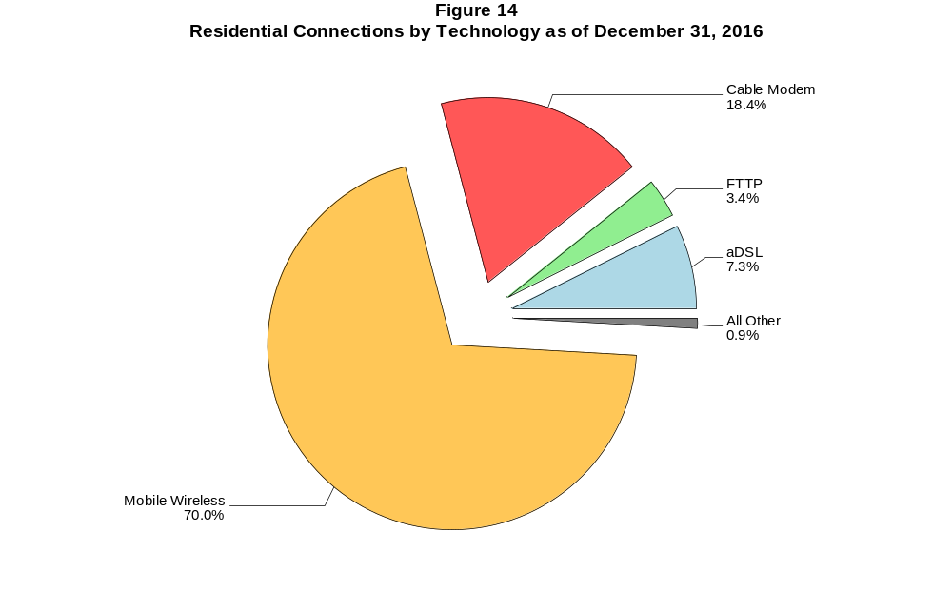

Figure 15
Fixed Connections at Least 3 Mbps Downstream and 768 kbps Upstream by Technology 2012-2016
(In thousands)

 | 2012 | 2013 |  | 2014 |  | 2015 |  | 2016
Technology | Dec | Jun | Dec | Jun* | Dec | Jun | Dec | Jun | Dec
Total | 64,657 | 68,673 | 78,175 | 78,981 | 83,872 | 88,985 | 92,352 | 95,492 | 98,781
aDSL | 13,108 | 14,233 | 18,540 | 17,246 | 18,557 | 20,939 | 20,741 | 21,150 | 21,042
sDSL | 33 | 34 | 36 | 33 | 28 | 24 | 20 | 20 | 20
Other Wireline¹ | 276 | 284 | 308 | 310 | 308 | 296 | 330 | 336 | 347
Cable Modem | 44,133 | 46,014 | 50,236 | 51,304 | 53,853 | 55,807 | 58,423 | 60,343 | 62,881
FTTP² | 6,430 | 6,981 | 7,486 | 8,111 | 8,974 | 9,551 | 10,384 | 11,013 | 11,942
Satellite | 394 | 791 | 1,181 | 1,424 | 1,558 | 1,690 | 1,744 | 1,775 | 1,609
Fixed Wireless | 284 | 337 | 388 | 553 | 594 | 677 | 710 | 856 | 939

¹ Power Line and Other are summarized with Other Wireline to maintain firm confidentiality. See Technical Notes at the end of the report for a description of Form
477 technology categories and other reporting requirements.
² Fiber to the premises.
* The June 2014 data have not been subjected to the typical quality checks (see Technical Notes).
# = Rounds to zero.

The Commission approved changes to the Form 477 in June 2013 that affect the data beginning in June 2014 (see Technical Notes). Some previously-published
data may have been revised. Figures may not sum to totals due to rounding.

Figure 16
Residential Fixed Connections at Least 3 Mbps Downstream and 768 kbps Upstream by Technology 2012-2016
(In thousands)

 | 2012 | 2013 |  | 2014 |  | 2015 |  | 2016
Technology | Dec | Jun | Dec | Jun* | Dec | Jun | Dec | Jun | Dec
Total | 59,914 | 63,342 | 72,476 | 73,042 | 77,540 | 82,300 | 85,435 | 88,179 | 91,272
aDSL | 11,669 | 12,666 | 16,715 | 15,673 | 16,867 | 18,985 | 18,863 | 19,210 | 19,133
sDSL | 13 | 13 | 13 | 7 | 2 | 1 | 2 | 2 | 3
Other Wireline¹ | 20 | 21 | 20 | 45 | 50 | 45 | 47 | 49 | 50
Cable Modem | 41,561 | 43,061 | 47,258 | 47,924 | 50,308 | 52,241 | 54,650 | 56,353 | 58,796
FTTP² | 6,012 | 6,504 | 6,958 | 7,491 | 8,246 | 8,750 | 9,513 | 10,050 | 10,876
Satellite | 393 | 788 | 1,177 | 1,419 | 1,552 | 1,682 | 1,734 | 1,764 | 1,596
Fixed Wireless | 245 | 289 | 335 | 483 | 516 | 596 | 626 | 751 | 817

¹ Power Line and Other are summarized with Other Wireline to maintain firm confidentiality. See Technical Notes at the end of the report for a description of Form
477 technology categories and other reporting requirements.
² Fiber to the premises.
* The June 2014 data have not been subjected to the typical quality checks (see Technical Notes).
# = Rounds to zero.

The Commission approved changes to the Form 477 in June 2013 that affect the data beginning in June 2014 (see Technical Notes). Some previously-published
data may have been revised. Figures may not sum to totals due to rounding.

Figure 17
Fixed Connections at Least 10 Mbps Downstream and 1 Mbps Upstream by Technology 2014-2016
(In thousands)

 | 2014 |  | 2015 |  | 2016
Technology | Jun* | Dec | Jun | Dec | Jun | Dec
Total | 63,849 | 68,009 | 72,691 | 76,939 | 80,440 | 84,131
aDSL | 7,573 | 8,310 | 9,463 | 9,799 | 10,352 | 10,811
sDSL | 9 | 6 | 8 | 8 | 8 | 10
Other Wireline¹ | 169 | 183 | 182 | 203 | 210 | 237
Cable Modem | 47,296 | 49,839 | 52,646 | 55,710 | 57,951 | 60,367
FTTP² | 7,615 | 8,341 | 8,873 | 9,575 | 10,126 | 10,990
Satellite | 1,016 | 1,137 | 1,298 | 1,393 | 1,467 | 1,342
Fixed Wireless | 170 | 192 | 220 | 252 | 326 | 375

¹ Power Line and Other are summarized with Other Wireline to maintain firm confidentiality. See Technical Notes at the end of the report for a description of
Form 477 technology categories and other reporting requirements.
² Fiber to the premises.
* The June 2014 data have not been subjected to the typical quality checks (see Technical Notes).
# = Rounds to zero.

The Commission approved changes to the Form 477 in June 2013 that affect the data beginning in June 2014 (see Technical Notes).
Figures may not sum to totals due to rounding.

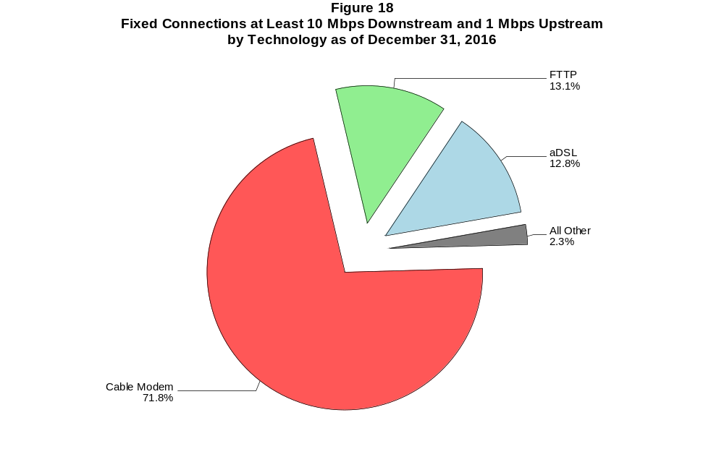

Figure 19
Residential Fixed Connections at Least 10 Mbps Downstream and 1 Mbps Upstream
by Technology 2014-2016
(In thousands)

 | 2014 |  | 2015 |  | 2016
Technology | Jun* | Dec | Jun | Dec | Jun | Dec
Total | 59,751 | 63,522 | 67,881 | 71,784 | 74,827 | 78,219
aDSL | 7,035 | 7,741 | 8,740 | 9,069 | 9,529 | 9,963
sDSL | 3 | # | # | 1 | 2 | 2
Other Wireline¹ | 33 | 36 | 38 | 43 | 47 | 49
Cable Modem | 44,480 | 46,767 | 49,475 | 52,294 | 54,274 | 56,549
FTTP² | 7,044 | 7,679 | 8,144 | 8,776 | 9,235 | 9,997
Satellite | 1,014 | 1,133 | 1,293 | 1,386 | 1,460 | 1,333
Fixed Wireless | 142 | 166 | 190 | 213 | 280 | 326

¹ Power Line and Other are summarized with Other Wireline to maintain firm confidentiality. See Technical Notes at the end of the report for a description of
Form 477 technology categories and other reporting requirements.
² Fiber to the premises.
* The June 2014 data have not been subjected to the typical quality checks (see Technical Notes).
# = Rounds to zero.

The Commission approved changes to the Form 477 in June 2013 that affect the data beginning in June 2014 (see Technical Notes).
Figures may not sum to totals due to rounding.

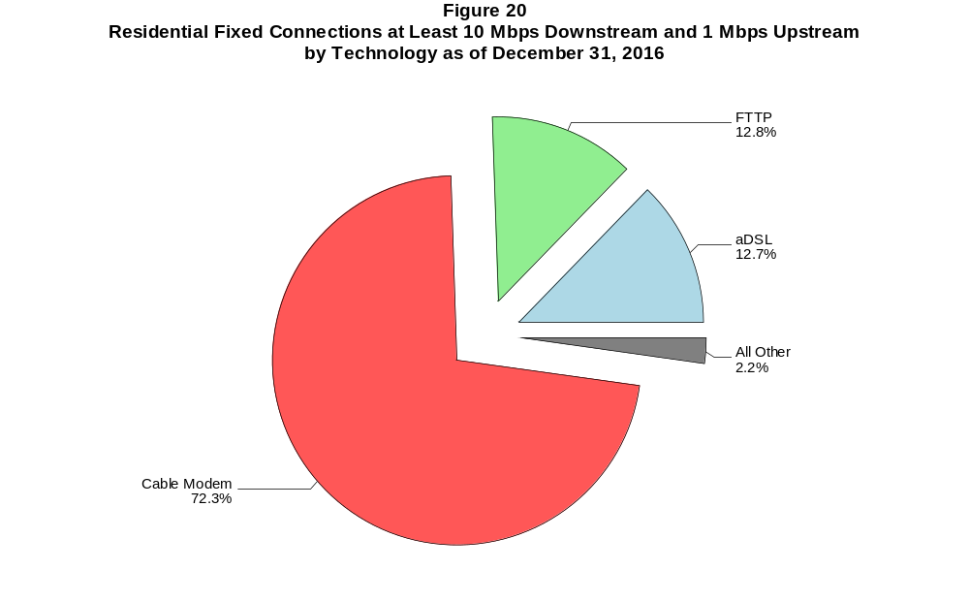

Figure 21
Fixed Connections at Least 25 Mbps Downstream and 3 Mbps Upstream by Technology 2014-2016
(In thousands)

 | 2014 |  | 2015 |  | 2016
Technology | Jun+ | Dec | Jun | Dec | Jun | Dec
Total | 35,927 | 42,390 | 48,449 | 54,335 | 58,740 | 62,929
aDSL | 420 | 598 | 761 | 938 | 1,240 | 1,476
sDSL | 2 | 2 | 1 | * | * | *
Other Wireline¹ | 114 | 125 | 125 | 141 | 158 | 188
Cable Modem | 30,769 | 36,095 | 40,646 | 45,530 | 48,696 | 51,755
FTTP² | 4,603 | 5,542 | 6,870 | 7,691 | 8,598 | 9,442
Satellite | # | # | # | * | * | *
Fixed Wireless | 19 | 28 | 47 | 55 | 69 | 87

¹ Power Line and Other are summarized with Other Wireline to maintain firm confidentiality. See Technical Notes at the end of the report for a description of
Form 477 technology categories and other reporting requirements.
² Fiber to the premises.
+ The June 2014 data have not been subjected to the typical quality checks (see Technical Notes).
* = Data withheld to maintain firm confidentiality.
# = Rounds to zero.

The Commission approved changes to the Form 477 in June 2013 that affect the data beginning in June 2014 (see Technical Notes).
Figures may not sum to totals due to rounding.

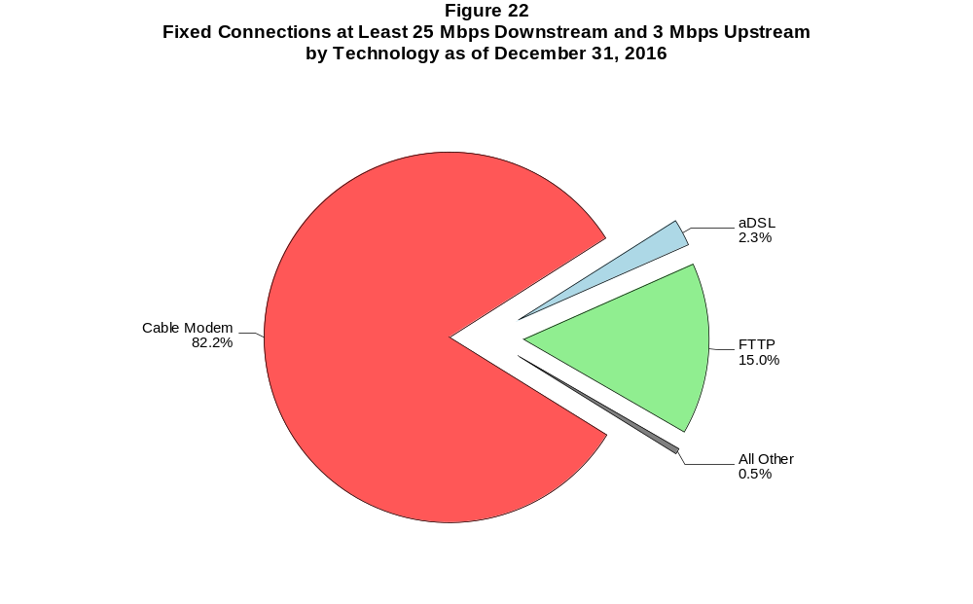

Figure 23
Residential Fixed Connections at Least 25 Mbps Downstream and 3 Mbps Upstream
by Technology 2014-2016
(In thousands)

 | 2014 |  | 2015 |  | 2016
Technology | Jun+ | Dec | Jun | Dec | Jun | Dec
Total | 34,439 | 40,595 | 46,198 | 51,788 | 55,685 | 59,485
aDSL | 397 | 566 | 727 | 897 | 1,174 | 1,408
sDSL | # | # | # | * | * | *
Other Wireline¹ | 22 | 26 | 26 | 31 | 41 | 45
Cable Modem | 29,806 | 34,914 | 39,083 | 43,746 | 46,527 | 49,310
FTTP² | 4,201 | 5,068 | 6,323 | 7,089 | 7,908 | 8,670
Satellite | 0 | 0 | 0 | * | * | *
Fixed Wireless | 14 | 22 | 40 | 46 | 55 | 72

¹ Power Line and Other are summarized with Other Wireline to maintain firm confidentiality. See Technical Notes at the end of the report for a description of
Form 477 technology categories and other reporting requirements.
² Fiber to the premises.
+ The June 2014 data have not been subjected to the typical quality checks (see Technical Notes).
* = Data withheld to maintain firm confidentiality.
# = Rounds to zero.

The Commission approved changes to the Form 477 in June 2013 that affect the data beginning in June 2014 (see Technical Notes).
Figures may not sum to totals due to rounding.

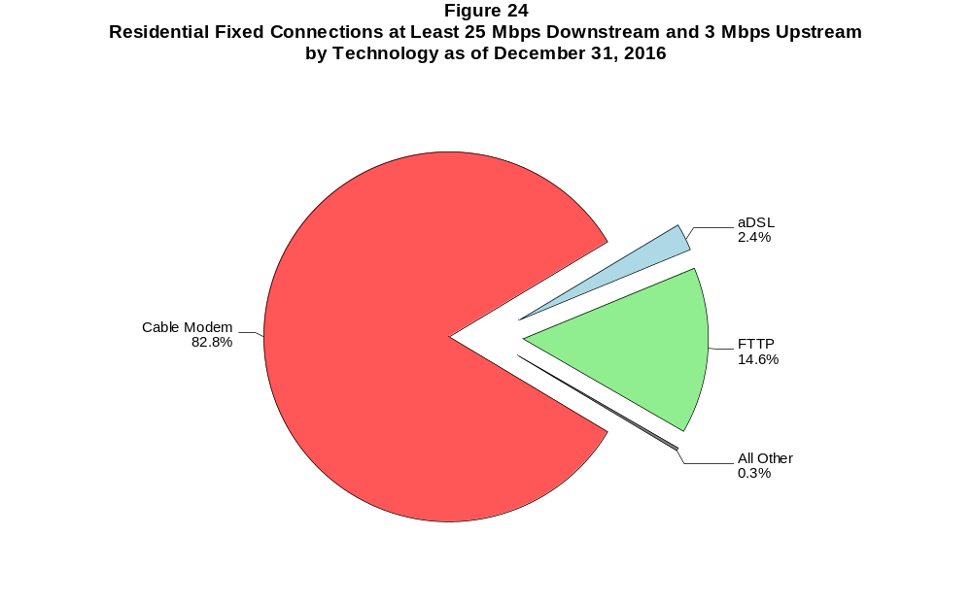

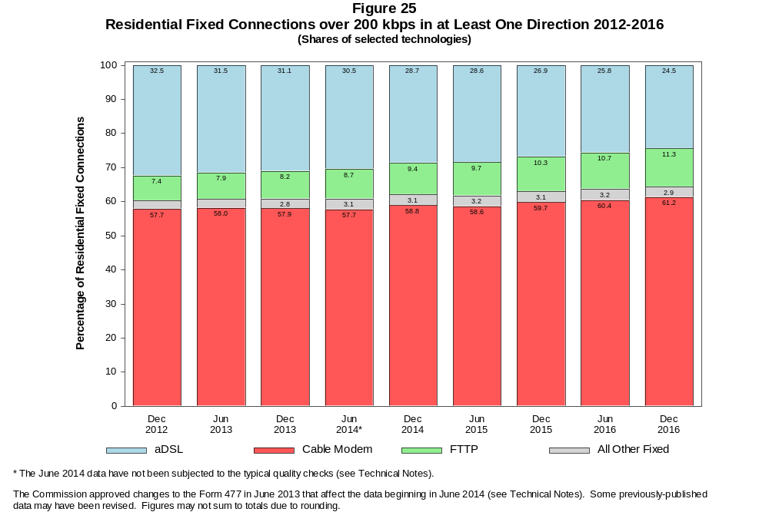

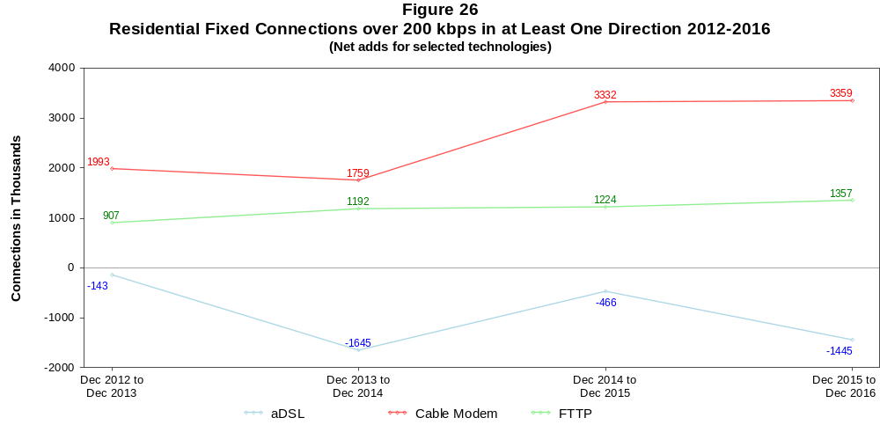

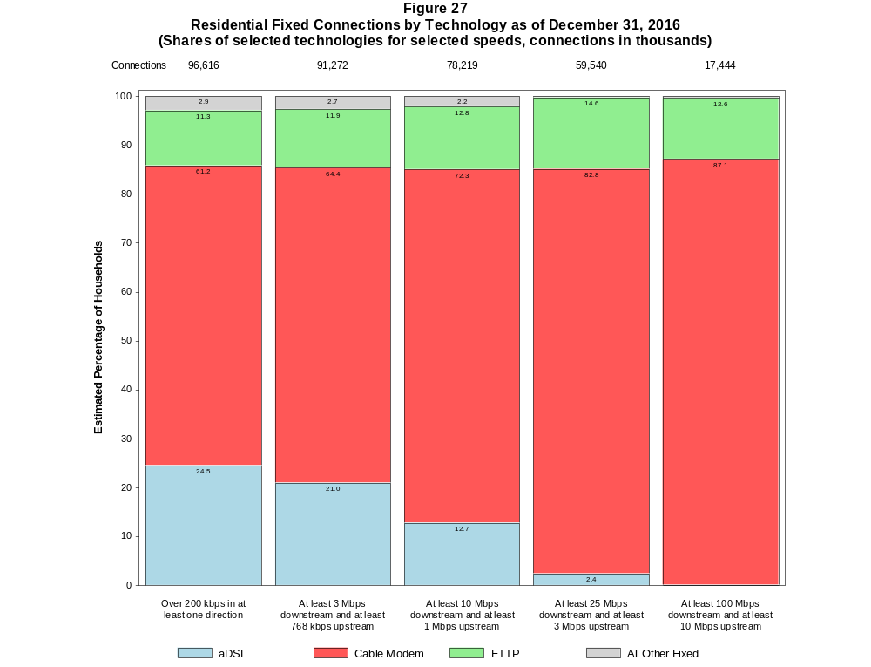

Figure 28
Fixed Connections by Downstream Speed Tier and Technology as of December 31, 2016
(In thousands)

 | Downstream Speed
Technology | Less than  1.5 Mbps | At least 1.5 Mbps  and less than  3 Mbps | At least 3 Mbps  and less than  10 Mbps | At least 10 Mbps  and less than  25 Mbps | At least 25 Mbps  and less than  100 Mbps | At least 100 Mbps | Total
aDSL | 988 | 1,797 | 10,635 | 11,361 | 1,740 | 6 | 26,526
sDSL | 13 | 9 | 10 | 7 | * | * | 42
Other Wireline¹ | 53 | 271 | 112 | 47 | 34 | 156 | 673
Cable Modem | 74 | 100 | 2,688 | 8,549 | 30,077 | 21,864 | 63,352
FTTP | 29 | 40 | 637 | 1,848 | 7,000 | 2,486 | 12,041
Satellite | 217 | 34 | 271 | 1,307 | * | * | 1,864
Fixed Wireless | 86 | 157 | 612 | 288 | 59 | 29 | 1,230
Total | 1,460 | 2,408 | 14,964 | 23,407 | 38,946 | 24,541 | 105,727

Percentages

aDSL | 0.9 | 1.7 | 10.1 | 10.7 | 1.6 | 0.0 | 25.1
sDSL | 0.0 | 0.0 | 0.0 | 0.0 | * | * | 0.0
Other Wireline¹ | 0.0 | 0.3 | 0.1 | 0.0 | 0.0 | 0.1 | 0.6
Cable Modem | 0.1 | 0.1 | 2.5 | 8.1 | 28.4 | 20.7 | 59.9
FTTP | 0.0 | 0.0 | 0.6 | 1.7 | 6.6 | 2.4 | 11.4
Satellite | 0.2 | 0.0 | 0.3 | 1.2 | * | * | 1.8
Fixed Wireless | 0.1 | 0.1 | 0.6 | 0.3 | 0.1 | 0.0 | 1.2
Total | 1.4 | 2.3 | 14.2 | 22.1 | 36.8 | 23.2 | 100.0

¹ Power Line and Other are summarized with Other Wireline to maintain firm confidentiality. See Technical Notes at the end of the report for a description of Form 477 technology categories
and other reporting requirements.
# = Rounds to Zero.
* = Data withheld to maintain firm confidentiality.
Note: Figures may not sum to totals due to rounding.
Source: FCC Form 477.

Figure 29
Residential Fixed Connections by Downstream Speed Tier and Technology as of December 31, 2016
(In thousands)

 | Downstream Speed
Technology | Less than  1.5 Mbps | At least 1.5 Mbps  and less than  3 Mbps | At least 3 Mbps  and less than  10 Mbps | At least 10 Mbps  and less than  25 Mbps | At least 25 Mbps  and less than  100 Mbps | At least 100 Mbps | Total
aDSL | 876 | 1,457 | 9,256 | 10,449 | 1,648 | 5 | 23,691
sDSL | 4 | 1 | # | 1 | * | * | 8
Other Wireline¹ | # | 1 | 1 | 4 | 8 | 37 | 52
Cable Modem | 68 | 57 | 2,393 | 7,162 | 28,130 | 21,349 | 59,158
FTTP | 17 | 29 | 566 | 1,628 | 6,511 | 2,198 | 10,949
Satellite | 66 | 12 | 265 | 1,299 | * | * | 1,676
Fixed Wireless | 78 | 142 | 537 | 254 | 50 | 23 | 1,082
Total | 1,109 | 1,698 | 13,018 | 20,796 | 36,382 | 23,612 | 96,616

Percentages

aDSL | 0.9 | 1.5 | 9.6 | 10.8 | 1.7 | 0.0 | 24.5
sDSL | 0.0 | 0.0 | 0.0 | 0.0 | * | * | 0.0
Other Wireline¹ | 0.0 | 0.0 | 0.0 | 0.0 | 0.0 | 0.0 | 0.1
Cable Modem | 0.1 | 0.1 | 2.5 | 7.4 | 29.1 | 22.1 | 61.2
FTTP | 0.0 | 0.0 | 0.6 | 1.7 | 6.7 | 2.3 | 11.3
Satellite | 0.1 | 0.0 | 0.3 | 1.3 | * | * | 1.7
Fixed Wireless | 0.1 | 0.1 | 0.6 | 0.3 | 0.1 | 0.0 | 1.1
Total | 1.1 | 1.8 | 13.5 | 21.5 | 37.7 | 24.4 | 100.0

¹ Power Line and Other are summarized with Other Wireline to maintain firm confidentiality. See Technical Notes at the end of the report for a description of Form 477 technology categories
and other reporting requirements.
# = Rounds to Zero.
* = Data withheld to maintain firm confidentiality.
Note: Figures may not sum to totals due to rounding.
Source: FCC Form 477.

Figure 30
Nationwide Number of Providers of Connections over 200 kbps in at Least One Direction
by Technology 2012-2016

 | 2012 | 2013 |  | 2014 |  | 2015 |  | 2016
Technology | Dec | Jun | Dec | Jun+ | Dec | Jun | Dec | Jun | Dec
aDSL | 865 | 852 | 851 | 794 | 792 | 790 | 775 | 766 | 772
sDSL | 255 | 246 | 239 | 195 | 191 | 177 | 181 | 171 | 158
Other Wireline¹ | 262 | 246 | 245 | 270 | 245 | 239 | 250 | 241 | 234
Cable Modem | 404 | 403 | 407 | 394 | 402 | 391 | 392 | 387 | 386
FTTP | 666 | 692 | 744 | 878 | 906 | 929 | 990 | 1,010 | 1,062
Satellite | 6 | 5 | 5 | 18 | 16 | 11 | 11 | 6 | 6
Fixed Wireless | 765 | 771 | 825 | 870 | 916 | 943 | 977 | 1,004 | 1,047
Mobile Wireless | 70 | 79 | 77 | 91 | 98 | 100 | 97 | 99 | 98
Power Line and Other¹ | * | 0 | * | - | - | - | - | - | -
Total | 1,722 | 1,714 | 1,773 | 1,813 | 1,865 | 1,874 | 1,911 | 1,932 | 1,977

¹ For this Figure, the categories Power Line and All Other were combined with Other Wireline from June 2014 forward.
+ The June 2014 data have not been subjected to the typical quality checks (see Technical Notes).
Multiple Form 477 filers within a holding company structure count as one provider. * = 1-3 providers.

The Commission approved changes to the Form 477 in June 2013 that affect the data beginning in June 2014 (see Technical Notes). Some previously-published
data may have been revised.

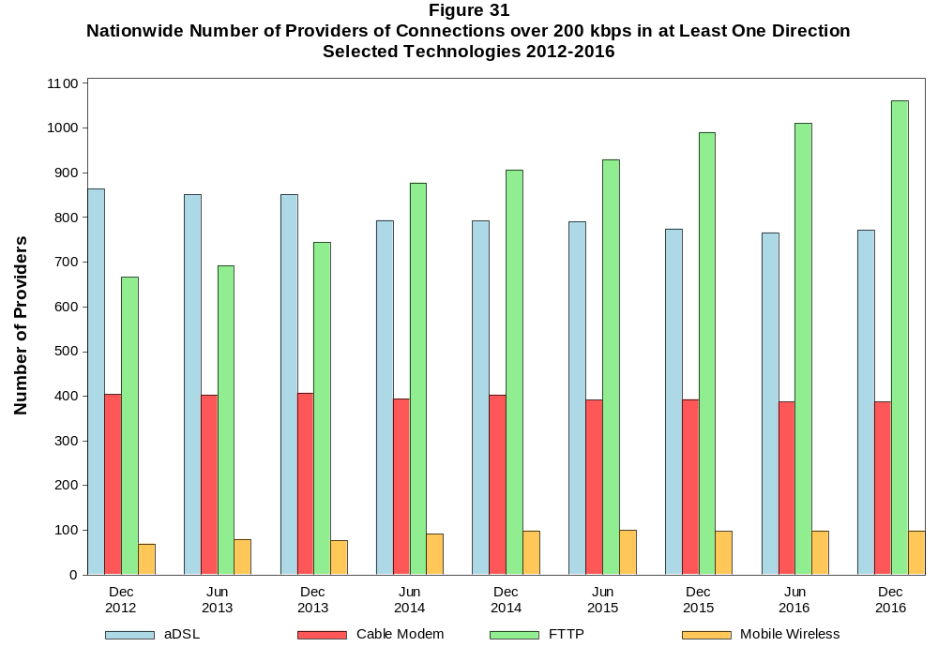

Figure 32
Residential Fixed Connections and Households by State as of December 31, 2016
(Connections and households, in thousands)

 |  | At least 200 kbps in  at least One Direction |  | At least 10 Mbps Down  and 1 Mbps Up |  | At least 25 Mbps Down  and 3 Mbps Up |  | At least 100 Mbps Down  and 10 Mbps Up
State | Households | Connections | Subscribership  Ratio | Connections | Subscribership  Ratio | Connections | Subscribership  Ratio | Connections | Subscribership  Ratio
Alabama | 1,848 | 1,290 | 0.70 | 955 | 0.52 | 653 | 0.35 | 68 | 0.04
Alaska | 251 | 204 | 0.81 | 146 | 0.58 | * | * | * | *
American Samoa | 10 | * | * | 0 | 0.00 | 0 | 0.00 | 0 | 0.00
Arizona | 2,412 | 2,044 | 0.85 | 1,520 | 0.63 | 1,237 | 0.51 | 383 | 0.16
Arkansas | 1,138 | 742 | 0.65 | 501 | 0.44 | 270 | 0.24 | 48 | 0.04
California | 12,718 | 10,986 | 0.86 | 9,326 | 0.73 | 7,081 | 0.56 | 2,827 | 0.22
Colorado | 2,024 | 1,802 | 0.89 | 1,333 | 0.66 | 1,223 | 0.60 | * | *
Connecticut | 1,353 | 1,185 | 0.88 | 1,035 | 0.77 | 837 | 0.62 | 252 | 0.19
Delaware | 344 | 318 | 0.93 | 296 | 0.86 | 284 | 0.83 | 94 | 0.27
District of Columbia | 273 | 234 | 0.86 | 211 | 0.77 | 200 | 0.73 | * | *
Florida | 7,300 | 6,864 | 0.94 | 5,902 | 0.81 | 4,564 | 0.63 | 1,192 | 0.16
Georgia | 3,574 | 2,882 | 0.81 | 2,260 | 0.63 | 1,630 | 0.46 | 296 | 0.08
Guam | 42 | * | * | * | * | * | * | 0 | 0.00
Hawaii | 451 | 408 | 0.91 | 401 | 0.89 | * | * | * | *
Idaho | 589 | 473 | 0.80 | 255 | 0.43 | 191 | 0.32 | 14 | 0.02
Illinois | 4,786 | 3,759 | 0.79 | 3,108 | 0.65 | 2,321 | 0.48 | 438 | 0.09
Indiana | 2,502 | 1,893 | 0.76 | 1,443 | 0.58 | 992 | 0.40 | 228 | 0.09
Iowa | 1,236 | 917 | 0.74 | 587 | 0.47 | 469 | 0.38 | 92 | 0.07
Kansas | 1,113 | 881 | 0.79 | 658 | 0.59 | 404 | 0.36 | 174 | 0.16
Kentucky | 1,708 | 1,297 | 0.76 | 892 | 0.52 | 465 | 0.27 | 230 | 0.13
Louisiana | 1,728 | 1,212 | 0.70 | 949 | 0.55 | 620 | 0.36 | 136 | 0.08
Maine | 553 | 486 | 0.88 | 343 | 0.62 | 154 | 0.28 | 10 | 0.02
Maryland | 2,166 | 1,853 | 0.86 | 1,712 | 0.79 | 1,594 | 0.74 | 509 | 0.24
Massachusetts | 2,550 | 2,288 | 0.90 | 2,111 | 0.83 | 2,015 | 0.79 | 709 | 0.28
Michigan | 3,841 | 2,935 | 0.76 | 2,442 | 0.64 | 1,849 | 0.48 | 206 | 0.05
Minnesota | 2,125 | 1,703 | 0.80 | 1,231 | 0.58 | 1,081 | 0.51 | 257 | 0.12
Mississippi | 1,097 | 646 | 0.59 | 447 | 0.41 | 240 | 0.22 | 30 | 0.03
Missouri | 2,365 | 1,781 | 0.75 | 1,295 | 0.55 | 870 | 0.37 | 228 | 0.10
Montana | 409 | 325 | 0.79 | 211 | 0.51 | 181 | 0.44 | 7 | 0.02
Nebraska | 737 | 575 | 0.78 | 406 | 0.55 | 283 | 0.38 | 49 | 0.07

Figure 32 - Continued
Residential Fixed Connections and Households by State as of December 31, 2016
(Connections and households, in thousands)

 |  | At least 200 kbps in  at least One Direction |  | At least 10 Mbps Down  and 1 Mbps Up |  | At least 25 Mbps Down  and 3 Mbps Up |  | At least 100 Mbps Down  and 10 Mbps Up
State | Households | Connections | Subscribership  Ratio | Connections | Subscribership  Ratio | Connections | Subscribership  Ratio | Connections | Subscribership  Ratio
Nevada | 1,017 | 875 | 0.86 | 708 | 0.70 | 542 | 0.53 | * | *
New Hampshire | 520 | 479 | 0.92 | 403 | 0.77 | 359 | 0.69 | 139 | 0.27
New Jersey | 3,189 | 2,903 | 0.91 | 2,735 | 0.86 | 2,639 | 0.83 | 810 | 0.25
New Mexico | 764 | 538 | 0.70 | 306 | 0.40 | 269 | 0.35 | 71 | 0.09
New York | 7,262 | 6,249 | 0.86 | 5,707 | 0.79 | 4,760 | 0.66 | 1,373 | 0.19
North Carolina | 3,776 | 3,192 | 0.85 | 2,393 | 0.63 | 1,835 | 0.49 | 942 | 0.25
North Dakota | 300 | 228 | 0.76 | 193 | 0.64 | 144 | 0.48 | 24 | 0.08
Northern Mariana Isl | 16 | * | * | * | * | * | * | 0 | 0.00
Ohio | 4,585 | 3,791 | 0.83 | 2,959 | 0.65 | 1,388 | 0.30 | 76 | 0.02
Oklahoma | 1,455 | 1,002 | 0.69 | 711 | 0.49 | 430 | 0.30 | 115 | 0.08
Oregon | 1,533 | 1,289 | 0.84 | 1,011 | 0.66 | 886 | 0.58 | 262 | 0.17
Pennsylvania | 4,959 | 3,998 | 0.81 | 3,226 | 0.65 | 2,868 | 0.58 | 944 | 0.19
Puerto Rico | 1,244 | * | * | * | * | * | * | * | *
Rhode Island | 411 | 345 | 0.84 | 331 | 0.81 | 296 | 0.72 | * | *
South Carolina | 1,815 | 1,445 | 0.80 | 1,151 | 0.63 | 615 | 0.34 | 45 | 0.02
South Dakota | 331 | 252 | 0.76 | 210 | 0.64 | 156 | 0.47 | 13 | 0.04
Tennessee | 2,505 | 1,816 | 0.72 | 1,485 | 0.59 | 1,110 | 0.44 | 233 | 0.09
Texas | 9,149 | 7,122 | 0.78 | 5,763 | 0.63 | 3,724 | 0.41 | 1,555 | 0.17
Utah | 906 | 783 | 0.86 | 569 | 0.63 | 496 | 0.55 | 193 | 0.21
Vermont | 257 | 239 | 0.93 | 165 | 0.64 | 131 | 0.51 | 52 | 0.20
Virgin Islands | 43 | 22 | 0.51 | * | * | * | * | * | *
Virginia | 3,063 | 2,497 | 0.82 | 2,149 | 0.70 | 1,889 | 0.62 | 576 | 0.19
Washington | 2,669 | 2,340 | 0.88 | 1,865 | 0.70 | 1,703 | 0.64 | 633 | 0.24
West Virginia | 741 | 529 | 0.71 | 360 | 0.49 | 287 | 0.39 | 61 | 0.08
Wisconsin | 2,299 | 1,856 | 0.81 | 1,426 | 0.62 | 816 | 0.35 | 20 | 0.01
Wyoming | 227 | 175 | 0.77 | 123 | 0.54 | 102 | 0.45 | 1 | 0.00
Total | 118,281 | 96,616 | 0.82 | 78,219 | 0.66 | 59,540 | 0.50 | 17,444 | 0.15

# = Rounds to Zero; * = Data withheld to maintain firm confidentiality.
Note: Figures may not sum to totals due to rounding.
Sources: FCC Form 477 (Connections); 2011-2015 ACS 5-year estimates; Census 2010.

Figure 33
Connections by Type of End User by State as of December 31, 2016
(Connections over 200 kbps in at least one direction, in thousands)

 | Connections |  | Percentages
State | Residential | Business | Residential | Business | Total
Alabama | 4,568 | 620 | 88.1 | 11.9 | 5,188
Alaska | 789 | 123 | 86.5 | 13.5 | 913
American Samoa | * | * | * | * | *
Arizona | 6,374 | 996 | 86.5 | 13.5 | 7,370
Arkansas | 2,698 | 415 | 86.7 | 13.3 | 3,113
California | 39,783 | 7,492 | 84.2 | 15.8 | 47,275
Colorado | 5,639 | 901 | 86.2 | 13.8 | 6,540
Connecticut | 3,874 | 686 | 85.0 | 15.0 | 4,559
Delaware | 992 | 149 | 87.0 | 13.0 | 1,141
District of Columbia | 906 | 480 | 65.4 | 34.6 | 1,385
Florida | 19,666 | 3,460 | 85.0 | 15.0 | 23,127
Georgia | 9,711 | 1,583 | 86.0 | 14.0 | 11,294
Guam | 108 | 45 | 70.4 | 29.6 | 154
Hawaii | 1,588 | 207 | 88.5 | 11.5 | 1,795
Idaho | 1,559 | 237 | 86.8 | 13.2 | 1,796
Illinois | 13,180 | 2,231 | 85.5 | 14.5 | 15,410
Indiana | 6,265 | 868 | 87.8 | 12.2 | 7,133
Iowa | 2,990 | 506 | 85.5 | 14.5 | 3,496
Kansas | 3,708 | 463 | 88.9 | 11.1 | 4,170
Kentucky | 4,832 | 571 | 89.4 | 10.6 | 5,403
Louisiana | 4,657 | 652 | 87.7 | 12.3 | 5,309
Maine | 1,304 | 207 | 86.3 | 13.7 | 1,511
Maryland | 6,180 | 1,021 | 85.8 | 14.2 | 7,201
Massachusetts | 7,180 | 1,222 | 85.5 | 14.5 | 8,401
Michigan | 9,143 | 1,658 | 84.7 | 15.3 | 10,801
Minnesota | 5,499 | 940 | 85.4 | 14.6 | 6,440
Mississippi | 2,816 | 308 | 90.2 | 9.8 | 3,124
Missouri | 5,858 | 976 | 85.7 | 14.3 | 6,834
Montana | 979 | 133 | 88.0 | 12.0 | 1,112
Nebraska | 1,721 | 342 | 83.4 | 16.6 | 2,063
Nevada | 2,901 | 394 | 88.0 | 12.0 | 3,295
New Hampshire | 1,390 | 208 | 87.0 | 13.0 | 1,598
New Jersey | 9,906 | 1,775 | 84.8 | 15.2 | 11,681
New Mexico | 1,829 | 262 | 87.5 | 12.5 | 2,091
New York | 20,668 | 3,586 | 85.2 | 14.8 | 24,253
North Carolina | 9,626 | 1,584 | 85.9 | 14.1 | 11,210
North Dakota | 734 | 126 | 85.4 | 14.6 | 860
Northern Mariana Isl | * | * | * | * | *
Ohio | 11,625 | 1,799 | 86.6 | 13.4 | 13,424
Oklahoma | 3,668 | 566 | 86.6 | 13.4 | 4,234
Oregon | 4,095 | 658 | 86.2 | 13.8 | 4,753
Pennsylvania | 12,729 | 1,969 | 86.6 | 13.4 | 14,698
Puerto Rico | 3,368 | 261 | 92.8 | 7.2 | 3,629
Rhode Island | 1,054 | 174 | 85.9 | 14.1 | 1,228
South Carolina | 4,553 | 644 | 87.6 | 12.4 | 5,197
South Dakota | 795 | 106 | 88.3 | 11.7 | 901
Tennessee | 6,209 | 995 | 86.2 | 13.8 | 7,204
Texas | 25,829 | 4,727 | 84.5 | 15.5 | 30,556
Utah | 2,760 | 465 | 85.6 | 14.4 | 3,226
Vermont | 641 | 123 | 83.9 | 16.1 | 764
Virgin Islands | 105 | 15 | 87.9 | 12.1 | 120
Virginia | 7,895 | 1,468 | 84.3 | 15.7 | 9,363
Washington | 7,618 | 1,230 | 86.1 | 13.9 | 8,847
West Virginia | 1,582 | 187 | 89.4 | 10.6 | 1,769
Wisconsin | 5,554 | 946 | 85.4 | 14.6 | 6,500
Wyoming | 590 | 76 | 88.6 | 11.4 | 666
Total | 322,364 | 53,857 | 85.7 | 14.3 | 376,221

# = Rounds to Zero.
* = Data withheld to maintain firm confidentiality.
Figures may not sum to totals due to rounding.
Source: FCC Form 477.

Figure 34
Connections by Technology by State as of December 31, 2016
(Connections over 200 kbps in at least one direction, in thousands)

State | ADSL | SDSL | Other  Wireline¹ | Cable  Modem | Fiber | Satellite | Fixed  Wireless | Mobile  Wireless | Total
Alabama | 526 | # | * | 702 | 115 | * | 10 | 3,764 | 5,188
Alaska | 78 | # | 3 | * | 4 | * | 5 | 674 | 913
American Samoa | * | * | 0 | * | * | 0 | * | * | *
Arizona | 565 | # | * | 1,420 | 142 | * | 33 | 5,168 | 7,370
Arkansas | 350 | * | 3 | 383 | 21 | * | 7 | 2,299 | 3,113
California | 3,463 | 8 | * | 7,353 | 894 | * | 85 | 35,229 | 47,275
Colorado | * | # | 19 | 1,155 | 203 | * | 63 | 4,574 | 6,540
Connecticut | * | # | 4 | 941 | 9 | * | * | 3,259 | 4,559
Delaware | * | * | 4 | 207 | * | * | * | 796 | 1,141
District of Columbia | 35 | * | 7 | * | * | * | * | 1,116 | 1,385
Florida | 1,746 | # | * | 4,893 | 698 | * | 12 | 15,650 | 23,127
Georgia | 1,089 | # | * | 1,753 | 233 | * | 2 | 8,129 | 11,294
Guam | * | 0 | * | * | * | 0 | 0 | 113 | 154
Hawaii | * | * | 1 | * | 34 | * | 4 | 1,354 | 1,795
Idaho | 181 | * | 2 | 200 | 71 | * | 52 | 1,276 | 1,796
Illinois | 1,263 | 2 | * | 2,583 | 92 | * | 75 | 11,321 | 15,410
Indiana | 697 | # | * | 1,085 | 169 | * | 41 | 5,084 | 7,133
Iowa | 305 | 1 | * | 469 | 165 | * | 31 | 2,493 | 3,496
Kansas | 257 | # | * | 470 | 170 | * | 39 | 3,208 | 4,170
Kentucky | 472 | # | * | 783 | 93 | * | 18 | 3,994 | 5,403
Louisiana | 423 | * | 7 | 774 | 70 | * | 6 | 3,971 | 5,309
Maine | 129 | 1 | * | 381 | 8 | * | 3 | 975 | 1,511
Maryland | * | 1 | 16 | 1,035 | * | * | 4 | 5,191 | 7,201
Massachusetts | * | # | 20 | 1,807 | * | * | 3 | 5,899 | 8,401
Michigan | 878 | 3 | * | 2,132 | 30 | * | 45 | 7,609 | 10,801
Minnesota | 525 | 3 | * | 1,056 | 196 | * | 29 | 4,588 | 6,440
Mississippi | 336 | # | * | 308 | 19 | * | 2 | 2,401 | 3,124
Missouri | 741 | # | * | 898 | 177 | * | 39 | 4,896 | 6,834
Montana | 106 | # | * | 199 | 24 | * | 22 | 747 | 1,112
Nebraska | 162 | # | * | 381 | 53 | * | 23 | 1,433 | 2,063

Figure 34 - Continued
Connections by Technology by State as of December 31, 2016
(Connections over 200 kbps in at least one direction, in thousands)

State | ADSL | SDSL | Other  Wireline¹ | Cable  Modem | Fiber | Satellite | Fixed  Wireless | Mobile  Wireless | Total
Nevada | 239 | # | 6 | * | 14 | * | 13 | 2,337 | 3,295
New Hampshire | 81 | # | * | 415 | 26 | * | # | 1,066 | 1,598
New Jersey | 200 | # | 27 | 2,017 | * | * | 1 | 8,481 | 11,681
New Mexico | 250 | # | * | 269 | 36 | * | 20 | 1,501 | 2,091
New York | 498 | 2 | 37 | 4,755 | * | * | 5 | 17,365 | 24,253
North Carolina | 952 | # | * | 2,263 | 190 | * | 8 | 7,720 | 11,210
North Dakota | 49 | # | * | 126 | 75 | * | 5 | 602 | 860
Northern Mariana Isl | * | 0 | 0 | * | * | 0 | 0 | * | *
Ohio | 1,162 | # | * | 2,662 | 177 | * | 44 | 9,319 | 13,424
Oklahoma | 386 | # | * | 572 | 40 | * | 48 | 3,132 | 4,234
Oregon | 278 | 1 | * | 890 | 177 | * | 25 | 3,342 | 4,753
Pennsylvania | 696 | 1 | 26 | 2,675 | * | * | 8 | 10,332 | 14,698
Puerto Rico | * | 0 | * | * | 6 | * | 2 | 2,942 | 3,629
Rhode Island | * | * | 2 | * | * | * | * | 852 | 1,228
South Carolina | 476 | * | 7 | 944 | 106 | * | 3 | 3,626 | 5,197
South Dakota | 48 | * | # | 159 | 53 | * | 12 | 623 | 901
Tennessee | 570 | # | * | 1,137 | 218 | * | 10 | 5,200 | 7,204
Texas | 2,631 | 1 | * | 3,849 | 870 | * | 211 | 22,760 | 30,556
Utah | 185 | # | * | 452 | 149 | * | 53 | 2,377 | 3,226
Vermont | 120 | * | 3 | 137 | 21 | * | 1 | 475 | 764
Virgin Islands | * | 0 | * | * | * | * | * | * | 120
Virginia | 338 | # | * | 1,406 | 866 | * | 16 | 6,632 | 9,363
Washington | 478 | 1 | * | 1,743 | 229 | * | 30 | 6,290 | 8,847
West Virginia | * | * | 1 | 347 | 10 | * | 2 | 1,188 | 1,769
Wisconsin | 647 | 5 | 5 | * | 79 | * | 32 | 4,482 | 6,500
Wyoming | 52 | # | * | 108 | 11 | * | 19 | 468 | 666
Total | 26,526 | 42 | 673 | 63,352 | 12,041 | 1,864 | 1,230 | 270,494 | 376,221

¹ PowerLine and Other are summarized with Other Wireline to maintain firm confidentiality. See Technical Notes at the end of the report for a description of Form 477 technology categories and
other reporting requirements.
# = Rounds to Zero.
* = Data withheld to maintain firm confidentiality.
Figures may not sum to totals due to rounding.
Source: FCC Form 477.

Figure 35
Percentage of Fixed Connections by Downstream Speed by State as of December 31, 2016

 | Over 200 kbps Upstream and
State | % over 200 kbps  Downstream | % at least 3 Mbps  Downstream | % at least 10 Mbps  Downstream | % at least 25 Mbps  Downstream | % at least 100 Mbps  Downstream
Alabama | 99.3 | 93.3 | 75.9 | 49.7 | 6.9
Alaska | 97.7 | 87.0 | 71.5 | 49.1 | 38.0
American Samoa | * | * | * | * | *
Arizona | 99.7 | 96.5 | 84.8 | 59.2 | 21.9
Arkansas | 99.3 | 92.7 | 70.9 | 38.9 | 9.0
California | 99.7 | 97.2 | 82.8 | 61.7 | 32.8
Colorado | 99.7 | 95.1 | 86.0 | 65.5 | 41.9
Connecticut | 99.4 | 98.9 | 86.0 | 68.7 | 29.5
Delaware | 99.8 | 98.3 | 91.8 | 86.5 | 44.7
District of Columbia | 99.8 | 97.1 | 86.8 | 80.9 | 44.4
Florida | 99.6 | 97.3 | 88.2 | 65.3 | 17.0
Georgia | 99.1 | 95.5 | 79.0 | 55.3 | 10.3
Guam | * | * | * | * | *
Hawaii | 100.0 | 99.0 | 96.8 | 42.4 | 20.0
Idaho | 99.5 | 93.6 | 69.3 | 39.7 | 25.7
Illinois | 99.7 | 97.2 | 81.8 | 59.5 | 14.5
Indiana | 99.3 | 96.4 | 77.2 | 50.7 | 11.6
Iowa | 99.6 | 92.6 | 72.4 | 49.5 | 11.0
Kansas | 99.7 | 95.4 | 75.4 | 44.1 | 19.9
Kentucky | 99.1 | 94.2 | 69.6 | 35.4 | 16.8
Louisiana | 99.2 | 94.3 | 78.1 | 50.6 | 11.6
Maine | 98.9 | 94.8 | 69.4 | 30.4 | 3.9
Maryland | 99.8 | 98.0 | 90.6 | 83.6 | 38.2
Massachusetts | 99.9 | 98.1 | 91.0 | 85.2 | 46.3
Michigan | 99.3 | 96.9 | 82.4 | 61.2 | 7.2
Minnesota | 99.7 | 94.9 | 81.0 | 61.9 | 26.6
Mississippi | 98.9 | 91.8 | 70.0 | 38.5 | 13.7
Missouri | 99.4 | 94.0 | 76.8 | 48.8 | 35.0
Montana | 99.6 | 90.7 | 70.7 | 55.8 | 2.8
Nebraska | 99.6 | 95.7 | 74.7 | 48.5 | 9.5

Figure 35 - Continued
Percentage of Fixed Connections by Downstream Speed by State as of December 31, 2016

 | Over 200 kbps Upstream and
State | % over 200 kbps  Downstream | % at least 3 Mbps  Downstream | % at least 10 Mbps  Downstream | % at least 25 Mbps  Downstream | % at least 100 Mbps  Downstream
Nevada | 99.8 | 97.8 | 86.5 | 62.2 | 15.2
New Hampshire | 99.1 | 95.9 | 82.5 | 70.9 | 44.1
New Jersey | 99.7 | 98.3 | 93.3 | 88.8 | 36.5
New Mexico | 99.7 | 91.9 | 72.6 | 48.2 | 27.7
New York | 99.6 | 98.3 | 89.7 | 74.1 | 21.0
North Carolina | 99.3 | 95.9 | 78.7 | 55.4 | 27.6
North Dakota | 99.8 | 96.6 | 85.5 | 64.9 | 16.9
Northern Mariana Isl | * | * | * | * | *
Ohio | 99.7 | 97.0 | 78.3 | 35.7 | 2.7
Oklahoma | 99.6 | 96.0 | 70.9 | 42.5 | 14.4
Oregon | 99.7 | 95.6 | 84.3 | 67.3 | 34.7
Pennsylvania | 99.7 | 96.3 | 81.9 | 70.6 | 35.4
Puerto Rico | 99.9 | 80.0 | 47.4 | 18.6 | 0.8
Rhode Island | 99.6 | 98.6 | 94.1 | 83.7 | 21.3
South Carolina | 99.5 | 95.7 | 80.1 | 42.8 | 3.7
South Dakota | 99.6 | 96.6 | 84.9 | 61.2 | 6.3
Tennessee | 99.4 | 96.0 | 81.9 | 59.8 | 13.0
Texas | 99.7 | 97.0 | 80.3 | 50.8 | 26.3
Utah | 99.9 | 96.4 | 83.0 | 61.6 | 37.8
Vermont | 98.7 | 84.8 | 64.8 | 48.8 | 31.4
Virgin Islands | 99.9 | 85.1 | 42.7 | 13.6 | 0.7
Virginia | 99.6 | 96.7 | 85.7 | 73.0 | 29.3
Washington | 99.5 | 96.0 | 85.3 | 70.8 | 45.9
West Virginia | 98.9 | 97.2 | 66.4 | 52.9 | 22.6
Wisconsin | 99.1 | 95.1 | 79.0 | 43.6 | 1.9
Wyoming | 99.6 | 91.8 | 76.0 | 57.1 | 1.2
Total | 99.6 | 96.3 | 82.2 | 60.0 | 23.2

Figure 36
Providers of Connections by Technology by State as of December 31, 2016
(Connections over 200 kbps in at least one direction, in thousands)

State | ADSL | SDSL | Other  Wireline¹ | Cable  Modem | Fiber | Satellite | Fixed  Wireless | Mobile  Wireless | Total
Alabama | 25 | 6 | * | 20 | 38 | * | 22 | 6 | 92
Alaska | 13 | 4 | 12 | * | 9 | * | 15 | 8 | 39
American Samoa | * | * | 0 | * | * | 0 | * | * | *
Arizona | 24 | 4 | * | 16 | 34 | * | 37 | 7 | 99
Arkansas | 24 | * | 17 | 19 | 31 | * | 21 | 5 | 76
California | 39 | 14 | * | 28 | 63 | * | 92 | 6 | 182
Colorado | * | 7 | 30 | 18 | 51 | * | 58 | 9 | 132
Connecticut | * | 7 | 19 | 10 | 20 | * | * | 4 | 42
Delaware | * | * | 16 | 6 | * | * | * | 4 | 31
District of Columbia | 9 | * | 19 | * | * | * | * | 4 | 42
Florida | 25 | 10 | * | 23 | 59 | * | 29 | 5 | 112
Georgia | 31 | 6 | * | 34 | 74 | * | 20 | 4 | 121
Guam | * | 0 | * | * | * | 0 | 0 | 4 | 4
Hawaii | * | * | 7 | * | 9 | * | 5 | 5 | 22
Idaho | 27 | * | 14 | 19 | 34 | * | 37 | 10 | 80
Illinois | 61 | 9 | * | 21 | 91 | * | 75 | 8 | 189
Indiana | 41 | 7 | * | 14 | 59 | * | 60 | 5 | 124
Iowa | 103 | 20 | * | 48 | 140 | * | 81 | 35 | 232
Kansas | 29 | 11 | * | 28 | 60 | * | 51 | 9 | 116
Kentucky | 23 | 6 | * | 28 | 43 | * | 28 | 7 | 96
Louisiana | 17 | * | 22 | 19 | 33 | * | 13 | 5 | 67
Maine | 16 | 7 | * | 9 | 21 | * | 9 | 5 | 41
Maryland | * | 8 | 25 | 16 | * | * | 16 | 5 | 72
Massachusetts | * | 6 | 29 | 10 | * | * | 16 | 5 | 68
Michigan | 37 | 11 | * | 24 | 55 | * | 38 | 6 | 117
Minnesota | 49 | 11 | * | 22 | 71 | * | 47 | 5 | 129
Mississippi | 18 | 4 | * | 17 | 22 | * | 12 | 5 | 64
Missouri | 37 | 11 | * | 20 | 53 | * | 68 | 8 | 144
Montana | 24 | 5 | * | 9 | 29 | * | 25 | 6 | 63
Nebraska | 31 | 4 | * | 20 | 48 | * | 38 | 9 | 92

Figure 36 - Continued
Providers of Connections by Technology by State as of December 31, 2016
(Connections over 200 kbps in at least one direction, in thousands)

State | ADSL | SDSL | Other  Wireline¹ | Cable  Modem | Fiber | Satellite | Fixed  Wireless | Mobile  Wireless | Total
Nevada | 19 | 8 | 27 | * | 29 | * | 19 | 6 | 67
New Hampshire | 14 | 7 | * | 6 | 21 | * | 5 | 6 | 41
New Jersey | 20 | 7 | 34 | 11 | * | * | 10 | 4 | 68
New Mexico | 23 | 6 | * | 11 | 26 | * | 26 | 8 | 68
New York | 40 | 8 | 34 | 21 | * | * | 27 | 7 | 107
North Carolina | 26 | 7 | * | 26 | 51 | * | 22 | 6 | 99
North Dakota | 26 | 9 | * | 8 | 31 | * | 17 | 6 | 53
Northern Mariana Isl | * | 0 | 0 | * | * | 0 | 0 | * | *
Ohio | 41 | 7 | * | 30 | 67 | * | 57 | 4 | 149
Oklahoma | 38 | 9 | * | 13 | 42 | * | 42 | 12 | 100
Oregon | 44 | 12 | * | 18 | 55 | * | 44 | 6 | 107
Pennsylvania | 32 | 9 | 35 | 26 | * | * | 24 | 8 | 115
Puerto Rico | * | 0 | * | * | 6 | * | 5 | 5 | 15
Rhode Island | * | * | 9 | * | * | * | * | 4 | 25
South Carolina | 20 | * | 19 | 16 | 28 | * | 11 | 6 | 53
South Dakota | 24 | * | 13 | 7 | 34 | * | 26 | 8 | 78
Tennessee | 26 | 7 | * | 23 | 42 | * | 29 | 7 | 101
Texas | 67 | 14 | * | 38 | 100 | * | 135 | 9 | 246
Utah | 23 | 4 | * | 14 | 28 | * | 28 | 9 | 72
Vermont | 13 | * | 9 | 6 | 19 | * | 4 | 6 | 34
Virgin Islands | * | 0 | * | * | * | * | * | * | 8
Virginia | 30 | 10 | * | 20 | 53 | * | 29 | 6 | 106
Washington | 30 | 9 | * | 26 | 55 | * | 55 | 6 | 121
West Virginia | * | * | 15 | 17 | 17 | * | 12 | 6 | 54
Wisconsin | 49 | 11 | 27 | * | 62 | * | 46 | 6 | 124
Wyoming | 17 | 5 | * | 7 | 19 | * | 26 | 8 | 55
Total | 772 | 158 | 234 | 386 | 1,062 | 6 | 1,047 | 98 | 1,977

¹ Power Line and Other are summarized with Other Wireline. See Technical Notes at the end of the report for a description of Form 477 technology categories and other reporting requirements.
# = Rounds to Zero.
* = Data withheld to maintain firm confidentiality.
Figures may not sum to totals due to rounding.
Source: FCC Form 477.

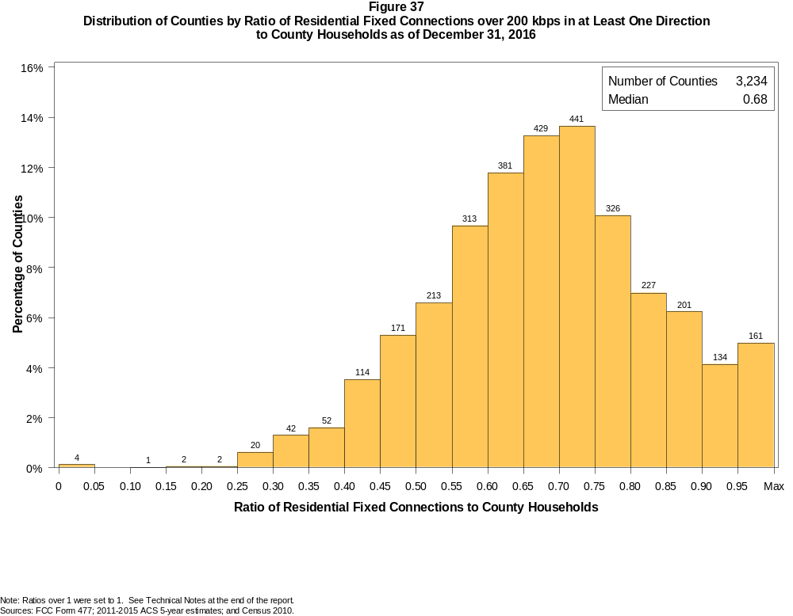

Figure 38
Distribution of Counties by Ratio of Residential Fixed Connections over 200 kbps in at Least One Direction
to County Households by Technology as of December 31, 2016

 | Ratio of Residential Fixed Connections to County Households
Technology | Zero | Greater than 0 and no more than 5% | Greater than 5 and no more than 10% | Greater than 10 and no more than 20% | Greater than 20 and no more than 30% | Greater than 30 and no more than 40% | Greater than 40 and no more than 50% | Greater than 50 and no more than 60% | Greater than 60 and no more than 80% | Greater than 80 and no more than 100% | 100% or more
aDSL | 0.9 | 5.5 | 5.8 | 25.3 | 30.5 | 17.9 | 8.8 | 3.3 | 1.5 | 0.3 | 0.1
sDSL | 90.2 | 9.7 | 0.1 | 0.0 | 0.0 | 0.0 | 0.0 | 0.0 | 0.0 | 0.0 | 0.0
Other Wireline | 92.4 | 7.5 | 0.1 | 0.0 | 0.0 | 0.0 | 0.0 | 0.0 | 0.0 | 0.0 | 0.0
Cable Modem | 11.6 | 7.3 | 6.8 | 14.9 | 13.9 | 14.0 | 11.8 | 10.2 | 8.2 | 1.0 | 0.3
FTTP | 25.4 | 46.6 | 7.8 | 8.4 | 4.0 | 2.8 | 2.1 | 1.4 | 1.5 | 0.1 | 0.0
Satellite | 1.1 | 67.0 | 22.0 | 8.8 | 1.1 | 0.1 | 0.0 | 0.0 | 0.0 | 0.0 | 0.0
Fixed Wireless | 28.3 | 51.1 | 11.0 | 6.4 | 2.2 | 0.6 | 0.2 | 0.0 | 0.0 | 0.0 | 0.0
Total | 0.1 | 0.0 | 0.0 | 0.1 | 0.7 | 2.9 | 8.8 | 16.3 | 48.7 | 19.6 | 2.7

¹ Power Line and Other are summarized with Other Wireline. See Technical Notes at the end of the report for a description of Form 477 technology categories and other reporting requirements.
Note: Figures may not sum to totals due to rounding.
Sources: FCC Form 477; 2011-2015 ACS 5-year estimates; and Census 2010.

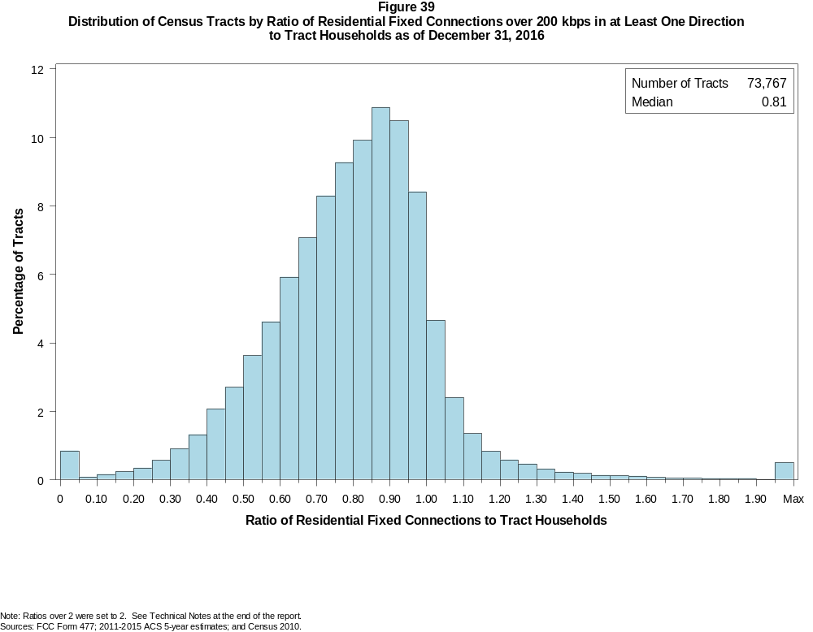

Figure 40
Distribution of Census Tracts by Ratio of Residential Fixed Connections over 200 kbps in at Least One Direction
to Tract Households by Technology as of December 31, 2016

 | Ratio of Residential Fixed Connections to Tract Households
Technology | Zero | Greater than 0 and no more than 5% | Greater than 5 and no more than 10% | Greater than 10 and no more than 20% | Greater than 20 and no more than 30% | Greater than 30 and no more than 40% | Greater than 40 and no more than 50% | Greater than 50 and no more than 60% | Greater than 60 and no more than 80% | Greater than 80 and no more than 100% | 100% or more
aDSL | 2.0 | 18.0 | 11.9 | 24.5 | 20.4 | 13.1 | 5.9 | 2.5 | 1.3 | 0.3 | 0.2
sDSL | 98.5 | 1.4 | 0.0 | 0.0 | 0.0 | 0.0 | 0.0 | 0.0 | 0.0 | 0.0 | 0.0
Other Wireline | 98.7 | 1.1 | 0.1 | 0.1 | 0.0 | 0.0 | 0.0 | 0.0 | 0.0 | 0.0 | 0.0
Cable Modem | 4.7 | 3.1 | 1.8 | 4.4 | 7.7 | 12.9 | 17.0 | 17.9 | 22.5 | 6.2 | 1.8
FTTP | 54.4 | 16.3 | 4.7 | 6.8 | 4.9 | 4.3 | 3.5 | 2.5 | 2.2 | 0.3 | 0.1
Satellite | 28.6 | 62.0 | 5.1 | 3.2 | 0.7 | 0.2 | 0.1 | 0.0 | 0.0 | 0.0 | 0.0
Fixed Wireless | 75.6 | 18.7 | 2.5 | 2.0 | 0.7 | 0.3 | 0.1 | 0.0 | 0.0 | 0.0 | 0.0
Total | 0.8 | 0.1 | 0.1 | 0.4 | 0.9 | 2.2 | 4.8 | 8.2 | 30.6 | 39.7 | 12.2

¹ Power Line and Other are summarized with Other Wireline. See Technical Notes at the end of the report for a description of Form 477 technology categories and other reporting requirements.
Note: Figures may not sum to totals due to rounding.
Sources: FCC Form 477; 2011-2015 ACS 5-year estimates; and Census 2010.

Figure 41
Percentage of Developed Census Blocks with Residential Fixed Service by Technology as of December 31, 2016
(Internet Access Service over 200 kbps in at least one direction)

 | Number of Providers
Technology | Zero | One | Two | Three | Four | Five | Six | Seven or More
aDSL | 26.3 | 69.8 | 3.7 | 0.1 | 0.0 | 0.0 | 0.0 | 0.0
sDSL | 99.3 | 0.7 | 0.0 | 0.0 | 0.0 | 0.0 | 0.0 | 0.0
Other Wireline¹ | 98.8 | 1.2 | 0.0 | 0.0 | 0.0 | 0.0 | 0.0 | 0.0
Cable Modem | 32.7 | 63.2 | 3.8 | 0.3 | 0.0 | 0.0 | 0.0 | 0.0
FTTP | 81.2 | 18.3 | 0.5 | 0.0 | 0.0 | 0.0 | 0.0 | 0.0
Satellite | 0.1 | 0.9 | 0.2 | 98.8 | 0.0 | 0.0 | 0.0 | 0.0
Fixed Wireless | 57.8 | 25.7 | 11.4 | 4.2 | 0.9 | 0.1 | 0.0 | 0.0
aDSL and/or Cable Modem and/or FTTP | 12.9 | 25.2 | 53.3 | 7.9 | 0.7 | 0.0 | 0.0 | 0.0
Any Technology | 0.0 | 0.2 | 0.1 | 6.7 | 18.4 | 40.9 | 21.0 | 12.7

¹ Power Line and Other are summarized with Other Wireline. See Technical Notes at the end of the report for a description of Form 477 technology categories and other reporting requirements.
Note: Figures may not sum to totals due to rounding. The number of providers in a census block does not necessarily reflect the number of choices available to a particular household, and does not
purport to measure competition. Providers may list a census block on Form 477 if service can be provided to at least one location in the block. Developed census blocks are those with housing units
based on the 2010 census.
Sources: FCC Form 477 and Census 2010.

Figure 42
Distribution of Counties by Ratio of Residential Fixed Connections to County Households by State as of December 31, 2016
(Connections over 200 kbps in at least one direction)

 |  | Ratio of Residential Fixed Connections over 200 kbps in at Least One Direction to County Households
State | Counties | Zero | Greater than 0 and no more than 5% | Greater than 5 and no more than 10% | Greater than 10 and no more than 20% | Greater than 20 and no more than 30% | Greater than 30 and no more than 40% | Greater than 40 and no more than 50% | Greater than 50 and no more than 60% | Greater than 60 and no more than 80% | Greater than 80 and no more than 100% | 100% or more
Alabama | 67 | 0 | 0 | 0 | 0 | 1 | 3 | 16 | 20 | 22 | 5 | 0
Alaska | 29 | 0 | 0 | 0 | 0 | 2 | 2 | 4 | 3 | 10 | 7 | 1
American Samoa | 5 | 2 | 0 | 0 | 0 | 2 | 0 | 1 | 0 | 0 | 0 | 0
Arizona | 15 | 0 | 0 | 0 | 0 | 0 | 0 | 1 | 2 | 6 | 6 | 0
Arkansas | 75 | 0 | 0 | 0 | 0 | 0 | 6 | 25 | 26 | 17 | 1 | 0
California | 58 | 0 | 0 | 0 | 0 | 0 | 0 | 0 | 0 | 21 | 34 | 3
Colorado | 64 | 0 | 0 | 0 | 0 | 0 | 0 | 2 | 7 | 23 | 23 | 9
Connecticut | 8 | 0 | 0 | 0 | 0 | 0 | 0 | 0 | 0 | 0 | 8 | 0
Delaware | 3 | 0 | 0 | 0 | 0 | 0 | 0 | 0 | 0 | 0 | 2 | 1
District of Columbia | 1 | 0 | 0 | 0 | 0 | 0 | 0 | 0 | 0 | 0 | 1 | 0
Florida | 67 | 0 | 0 | 0 | 0 | 0 | 0 | 0 | 8 | 17 | 25 | 17
Georgia | 159 | 0 | 0 | 0 | 1 | 3 | 9 | 18 | 33 | 57 | 31 | 7
Guam | 1 | 0 | 0 | 0 | 0 | 0 | 0 | 0 | 0 | 0 | 1 | 0
Hawaii | 5 | 1 | 0 | 0 | 0 | 0 | 0 | 0 | 0 | 1 | 2 | 1
Idaho | 44 | 0 | 0 | 0 | 0 | 0 | 0 | 1 | 4 | 29 | 8 | 2
Illinois | 102 | 0 | 0 | 0 | 0 | 1 | 0 | 3 | 17 | 70 | 11 | 0
Indiana | 92 | 0 | 0 | 0 | 0 | 0 | 0 | 2 | 18 | 62 | 10 | 0
Iowa | 99 | 0 | 0 | 0 | 0 | 0 | 0 | 2 | 8 | 82 | 6 | 1
Kansas | 105 | 0 | 0 | 0 | 0 | 1 | 1 | 3 | 18 | 67 | 14 | 1
Kentucky | 120 | 0 | 0 | 0 | 0 | 1 | 2 | 11 | 25 | 66 | 14 | 1
Louisiana | 64 | 0 | 0 | 0 | 0 | 1 | 6 | 14 | 11 | 30 | 2 | 0
Maine | 16 | 0 | 0 | 0 | 0 | 0 | 0 | 0 | 0 | 6 | 9 | 1
Maryland | 24 | 0 | 0 | 0 | 0 | 0 | 0 | 0 | 2 | 8 | 13 | 1
Massachusetts | 14 | 0 | 0 | 0 | 0 | 0 | 0 | 0 | 0 | 2 | 9 | 3
Michigan | 83 | 0 | 0 | 0 | 0 | 0 | 0 | 5 | 7 | 55 | 15 | 1
Minnesota | 87 | 0 | 0 | 0 | 0 | 0 | 0 | 0 | 6 | 64 | 16 | 1
Mississippi | 82 | 0 | 0 | 0 | 1 | 2 | 15 | 35 | 16 | 10 | 3 | 0
Missouri | 115 | 0 | 0 | 0 | 0 | 2 | 3 | 13 | 23 | 64 | 10 | 0
Montana | 56 | 0 | 0 | 0 | 0 | 0 | 0 | 0 | 8 | 30 | 17 | 1
Nebraska | 93 | 0 | 0 | 0 | 0 | 0 | 2 | 9 | 24 | 53 | 5 | 0

Figure 42 - Continued
Distribution of Counties by Ratio of Residential Fixed Connections to County Households by State as of December 31, 2016
(Connections over 200 kbps in at least one direction)

 |  | Ratio of Residential Fixed Connections over 200 kbps in at Least One Direction to County Households
State | Counties | Zero | Greater than 0 and no more than 5% | Greater than 5 and no more than 10% | Greater than 10 and no more than 20% | Greater than 20 and no more than 30% | Greater than 30 and no more than 40% | Greater than 40 and no more than 50% | Greater than 50 and no more than 60% | Greater than 60 and no more than 80% | Greater than 80 and no more than 100% | 100% or more
Nevada | 17 | 0 | 0 | 0 | 0 | 1 | 1 | 0 | 6 | 6 | 3 | 0
New Hampshire | 10 | 0 | 0 | 0 | 0 | 0 | 0 | 0 | 0 | 1 | 7 | 2
New Jersey | 21 | 0 | 0 | 0 | 0 | 0 | 0 | 0 | 0 | 2 | 18 | 1
New Mexico | 33 | 0 | 0 | 0 | 0 | 0 | 3 | 3 | 9 | 15 | 3 | 0
New York | 62 | 0 | 0 | 0 | 0 | 0 | 0 | 0 | 0 | 27 | 32 | 3
North Carolina | 100 | 0 | 0 | 0 | 0 | 0 | 0 | 1 | 16 | 47 | 29 | 7
North Dakota | 53 | 0 | 0 | 0 | 0 | 0 | 0 | 1 | 6 | 35 | 10 | 1
Northern Mariana Isl | 4 | 1 | 0 | 0 | 0 | 0 | 1 | 1 | 1 | 0 | 0 | 0
Ohio | 88 | 0 | 0 | 0 | 0 | 0 | 0 | 2 | 7 | 49 | 29 | 1
Oklahoma | 77 | 0 | 0 | 0 | 0 | 1 | 7 | 12 | 24 | 31 | 2 | 0
Oregon | 36 | 0 | 0 | 0 | 0 | 0 | 0 | 1 | 2 | 18 | 14 | 1
Pennsylvania | 67 | 0 | 0 | 0 | 0 | 0 | 0 | 0 | 0 | 46 | 19 | 2
Puerto Rico | 78 | 0 | 0 | 0 | 0 | 2 | 16 | 31 | 23 | 6 | 0 | 0
Rhode Island | 5 | 0 | 0 | 0 | 0 | 0 | 0 | 0 | 0 | 1 | 4 | 0
South Carolina | 46 | 0 | 0 | 0 | 0 | 0 | 1 | 8 | 11 | 16 | 7 | 3
South Dakota | 66 | 0 | 0 | 0 | 0 | 0 | 0 | 4 | 6 | 47 | 9 | 0
Tennessee | 95 | 0 | 0 | 0 | 0 | 0 | 2 | 9 | 30 | 46 | 7 | 1
Texas | 254 | 0 | 0 | 0 | 0 | 0 | 7 | 27 | 68 | 121 | 28 | 3
Utah | 29 | 0 | 0 | 0 | 0 | 0 | 0 | 0 | 1 | 13 | 11 | 4
Vermont | 14 | 0 | 0 | 0 | 0 | 0 | 0 | 0 | 0 | 3 | 9 | 2
Virgin Islands | 3 | 0 | 0 | 0 | 0 | 0 | 0 | 1 | 1 | 0 | 1 | 0
Virginia | 134 | 0 | 0 | 0 | 1 | 1 | 7 | 15 | 16 | 60 | 31 | 3
Washington | 39 | 0 | 0 | 0 | 0 | 0 | 0 | 1 | 3 | 15 | 19 | 1
West Virginia | 55 | 0 | 0 | 0 | 0 | 1 | 0 | 2 | 5 | 41 | 6 | 0
Wisconsin | 72 | 0 | 0 | 0 | 0 | 0 | 0 | 0 | 3 | 44 | 25 | 0
Wyoming | 23 | 0 | 0 | 0 | 0 | 0 | 0 | 1 | 3 | 14 | 4 | 1
Total | 3,234 | 4 | 0 | 0 | 3 | 22 | 94 | 285 | 527 | 1576 | 635 | 88

Note: Figures may not sum to totals due to rounding. See Technical Notes at the end of the report.
Sources: FCC Form 477; 2011-2015 ACS 5-year estimates (Households for U.S. and District of Columbia); Census 2010 (Households for Puerto Rico, American Samoa,
Guam, Northern Mariana Islands and U.S. Virgin Islands).

Figure 43
Distribution of Census Tracts by Ratio of Residential Fixed Connections to Tract Households by State as of December 31, 2016
(Connections over 200 kbps in at least one direction)

 |  | Ratio of Residential Fixed Connections over 200 kbps in at Least One Direction to Tract Households
State | Tracts | Zero | Greater than 0 and no more than 5% | Greater than 5 and no more than 10% | Greater than 10 and no more than 20% | Greater than 20 and no more than 30% | Greater than 30 and no more than 40% | Greater than 40 and no more than 50% | Greater than 50 and no more than 60% | Greater than 60 and no more than 80% | Greater than 80 and no more than 100% | 100% or more
Alabama | 1,179 | 4 | 0 | 1 | 4 | 26 | 91 | 173 | 213 | 376 | 220 | 71
Alaska | 167 | 2 | 0 | 0 | 2 | 7 | 4 | 4 | 11 | 50 | 73 | 14
American Samoa | 18 | 2 | 1 | 0 | 0 | 6 | 6 | 0 | 1 | 1 | 1 | 0
Arizona | 1,526 | 14 | 10 | 8 | 14 | 14 | 33 | 54 | 113 | 353 | 605 | 308
Arkansas | 686 | 1 | 0 | 0 | 8 | 22 | 57 | 133 | 128 | 218 | 93 | 26
California | 8,036 | 53 | 3 | 5 | 14 | 20 | 57 | 104 | 335 | 2,112 | 4,453 | 880
Colorado | 1,249 | 14 | 0 | 1 | 1 | 0 | 6 | 25 | 45 | 329 | 617 | 211
Connecticut | 829 | 2 | 0 | 0 | 0 | 2 | 1 | 7 | 36 | 172 | 487 | 122
Delaware | 215 | 1 | 0 | 0 | 0 | 1 | 1 | 3 | 11 | 54 | 99 | 45
District of Columbia | 179 | 0 | 0 | 0 | 1 | 0 | 1 | 5 | 14 | 53 | 73 | 32
Florida | 4,199 | 38 | 0 | 1 | 3 | 1 | 33 | 89 | 180 | 817 | 1,772 | 1,265
Georgia | 1,964 | 10 | 1 | 1 | 10 | 21 | 73 | 129 | 222 | 576 | 663 | 258
Guam | 56 | 4 | 3 | 1 | 3 | 6 | 2 | 1 | 5 | 6 | 6 | 19
Hawaii | 326 | 14 | 0 | 0 | 1 | 4 | 4 | 8 | 9 | 64 | 152 | 70
Idaho | 298 | 0 | 0 | 0 | 2 | 2 | 5 | 4 | 12 | 145 | 104 | 24
Illinois | 3,121 | 7 | 1 | 0 | 5 | 12 | 49 | 177 | 314 | 1,165 | 1,251 | 140
Indiana | 1,508 | 5 | 2 | 0 | 2 | 5 | 30 | 91 | 215 | 658 | 414 | 86
Iowa | 825 | 3 | 1 | 0 | 1 | 2 | 8 | 26 | 94 | 508 | 155 | 27
Kansas | 770 | 11 | 0 | 0 | 0 | 4 | 9 | 33 | 102 | 310 | 230 | 71
Kentucky | 1,115 | 9 | 2 | 1 | 9 | 15 | 29 | 65 | 161 | 409 | 302 | 113
Louisiana | 1,136 | 12 | 1 | 0 | 4 | 22 | 83 | 117 | 180 | 397 | 275 | 45
Maine | 351 | 0 | 0 | 0 | 0 | 3 | 2 | 1 | 9 | 103 | 164 | 69
Maryland | 1,394 | 8 | 0 | 0 | 0 | 2 | 27 | 48 | 74 | 337 | 718 | 180
Massachusetts | 1,471 | 12 | 1 | 0 | 0 | 1 | 6 | 12 | 34 | 317 | 863 | 225
Michigan | 2,767 | 28 | 1 | 0 | 14 | 43 | 124 | 208 | 256 | 855 | 1,095 | 143
Minnesota | 1,335 | 4 | 0 | 0 | 3 | 2 | 10 | 33 | 73 | 565 | 567 | 78
Mississippi | 661 | 4 | 0 | 0 | 5 | 32 | 103 | 145 | 116 | 165 | 74 | 17
Missouri | 1,393 | 5 | 0 | 0 | 4 | 11 | 46 | 128 | 191 | 476 | 416 | 116
Montana | 271 | 2 | 0 | 0 | 1 | 0 | 2 | 7 | 26 | 115 | 97 | 21
Nebraska | 532 | 4 | 0 | 0 | 0 | 0 | 5 | 26 | 48 | 243 | 157 | 49

Figure 43 - Continued
Distribution of Census Tracts by Ratio of Residential Fixed Connections to Tract Households by State as of December 31, 2016
(Connections over 200 kbps in at least one direction)

 |  | Ratio of Residential Fixed Connections over 200 kbps in at Least One Direction to Tract Households
State | Tracts | Zero | Greater than 0 and no more than 5% | Greater than 5 and no more than 10% | Greater than 10 and no more than 20% | Greater than 20 and no more than 30% | Greater than 30 and no more than 40% | Greater than 40 and no more than 50% | Greater than 50 and no more than 60% | Greater than 60 and no more than 80% | Greater than 80 and no more than 100% | 100% or more
Nevada | 683 | 5 | 0 | 1 | 4 | 4 | 8 | 21 | 49 | 163 | 296 | 132
New Hampshire | 294 | 2 | 0 | 0 | 0 | 0 | 0 | 1 | 2 | 37 | 199 | 53
New Jersey | 2,004 | 11 | 0 | 0 | 0 | 2 | 2 | 12 | 55 | 418 | 1,148 | 356
New Mexico | 499 | 2 | 4 | 4 | 7 | 10 | 18 | 41 | 82 | 182 | 124 | 25
New York | 4,900 | 78 | 1 | 0 | 13 | 15 | 22 | 55 | 162 | 1,480 | 2,408 | 666
North Carolina | 2,183 | 19 | 3 | 0 | 2 | 7 | 14 | 69 | 188 | 711 | 714 | 456
North Dakota | 205 | 0 | 0 | 0 | 0 | 0 | 1 | 7 | 24 | 113 | 44 | 16
Northern Mariana Isl | 22 | 2 | 0 | 0 | 1 | 3 | 4 | 2 | 5 | 2 | 1 | 2
Ohio | 2,946 | 6 | 0 | 0 | 3 | 11 | 47 | 152 | 226 | 997 | 1,109 | 395
Oklahoma | 1,046 | 2 | 2 | 3 | 11 | 38 | 50 | 141 | 182 | 334 | 199 | 84
Oregon | 827 | 2 | 0 | 0 | 0 | 0 | 3 | 21 | 27 | 255 | 451 | 68
Pennsylvania | 3,217 | 22 | 0 | 0 | 3 | 16 | 13 | 72 | 222 | 1,313 | 1,312 | 244
Puerto Rico | 903 | 24 | 26 | 28 | 101 | 130 | 144 | 144 | 94 | 96 | 33 | 83
Rhode Island | 241 | 1 | 0 | 0 | 0 | 0 | 0 | 3 | 8 | 72 | 135 | 22
South Carolina | 1,097 | 11 | 0 | 0 | 1 | 12 | 34 | 106 | 133 | 337 | 300 | 163
South Dakota | 222 | 0 | 0 | 1 | 0 | 0 | 4 | 9 | 17 | 128 | 53 | 10
Tennessee | 1,497 | 22 | 1 | 0 | 7 | 28 | 75 | 120 | 235 | 536 | 366 | 107
Texas | 5,253 | 41 | 0 | 1 | 15 | 87 | 211 | 496 | 725 | 1,577 | 1,490 | 610
Utah | 588 | 4 | 1 | 2 | 2 | 0 | 0 | 3 | 17 | 170 | 316 | 73
Vermont | 184 | 1 | 0 | 0 | 0 | 0 | 1 | 0 | 1 | 47 | 91 | 43
Virgin Islands | 29 | 0 | 0 | 0 | 2 | 3 | 5 | 4 | 4 | 9 | 1 | 1
Virginia | 1,895 | 23 | 0 | 0 | 5 | 21 | 53 | 100 | 179 | 453 | 804 | 257
Washington | 1,446 | 3 | 0 | 0 | 2 | 4 | 10 | 27 | 30 | 324 | 827 | 219
West Virginia | 484 | 0 | 1 | 2 | 3 | 5 | 18 | 34 | 72 | 214 | 102 | 33
Wisconsin | 1,393 | 3 | 1 | 0 | 2 | 2 | 5 | 38 | 94 | 569 | 556 | 123
Wyoming | 132 | 1 | 0 | 0 | 0 | 1 | 1 | 5 | 10 | 65 | 42 | 7
Total | 73,767 | 558 | 67 | 61 | 295 | 685 | 1,650 | 3,539 | 6,071 | 22,551 | 29,317 | 8,973

Note: Figures may not sum to totals due to rounding. See Technical Notes at the end of the report.
Sources: FCC Form 477; 2011-2015 ACS 5-year estimates (Households for U.S. and District of Columbia); Census 2010 (Households for Puerto Rico, American Samoa,
Guam, Northern Mariana Islands and U.S. Virgin Islands).

